✅ Step-by-Step Jenkins Job Setup

🔧 Prerequisites
- Jenkins installed and running
- Java and Maven installed on Jenkins server/agent
- Git installed
- Jenkins plugins:
  - Git Plugin
  - Maven Integration Plugin
  - (Optional) SonarQube Scanner Plugin
  - (Optional) Artifactory Plugin

🧩 Step 1: Create a New Jenkins Job
- Go to Jenkins dashboard → New Item
- Enter name: mahalogin-pipeline
- Select Freestyle project → Click OK

🔗 Step 2: Configure Source Code Management
- Go to Source Code Management → Select Git
- Repository URL: https://github.com/AbdulRehaman082493/mahalogin.git
- Branches to build:
*/main

⏰ Step 3: Configure Build Triggers
Choose one of the following:
- Poll SCM:
H/15 * * * * # Every 15 mins
- GitHub webhook (preferred for faster trigger):
- In GitHub, go to repo → Settings → Webhooks → Add:
http://<jenkins-url>/github-webhook/

🧹 Step 4: Configure Build Environment (Optional)
- ☑️ Check Delete workspace before build starts (clean build)
- ☑️ Add environment variables if needed

🔨 Step 5: Add Build Step – Maven Build
- Build → Add build step → Invoke top-level Maven targets
- Set:
  - Goals:
clean install
- POM:pom.xml

(Optional) 🧪 Step 6: Code Analysis using SonarQube
If SonarQube is configured:
- Add Build Step → Invoke SonarQube Scanner
- Set project properties or use sonar-project.properties

📦 Step 7: Archive the Build Artifacts
- Post-build Actions → Archive the artifacts
- Set: target/*.war

(Optional) 📤 Step 8: Upload to JFrog Artifactory
If integrated:
- Add Post-build Action → Deploy artifacts to Artifactory
- Configure:
  - Artifactory server
  - Target repository
  - Artifact pattern: target/*.war

🔁 Step 9: Save and Run
- Click Save
- Click Build Now
- Observe Console Output to verify the flow

📝 Summary Flow

Step | Action
1 | Jenkins polls GitHub repo or listens to webhook
2 | Clones main branch of mahalogin.git
3 | Cleans and compiles Java source code
4 | Runs unit tests
5 | Generates .war artifact
6 | (Optional) Runs SonarQube code analysis
7 | Archives .war file
8 | (Optional) Uploads to JFrog repo

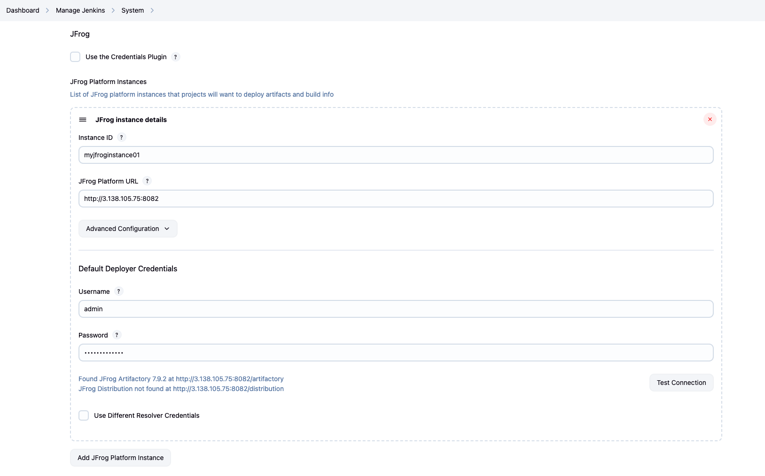

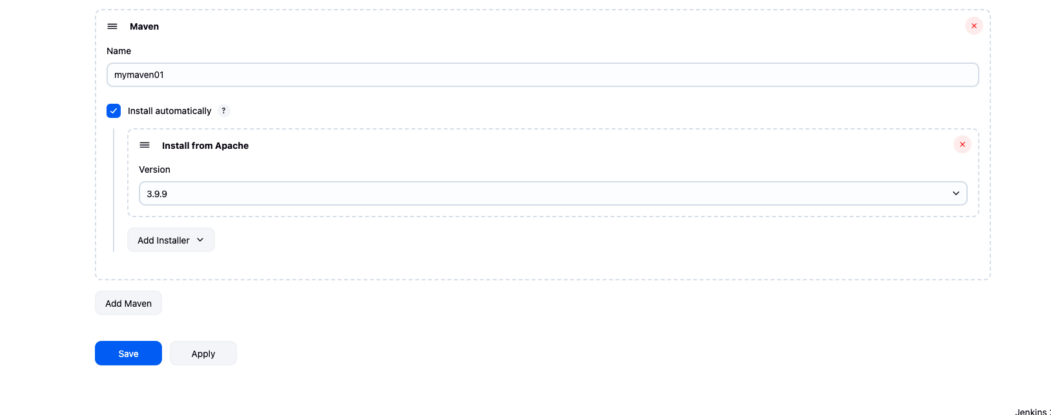

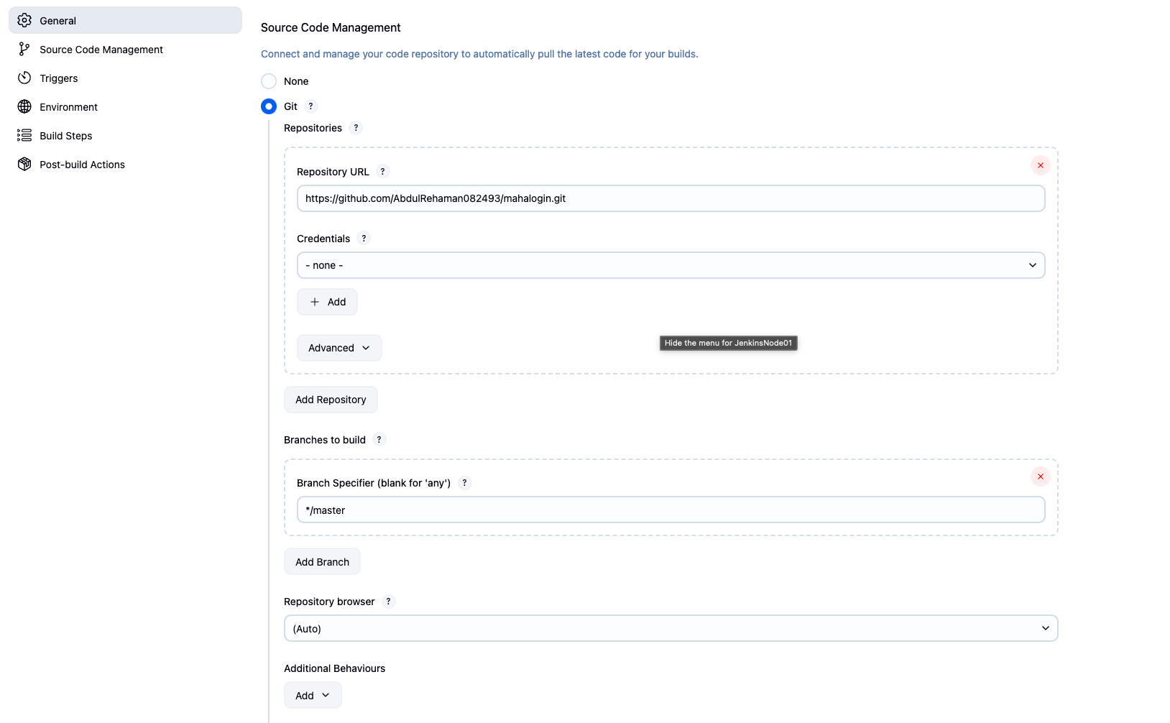

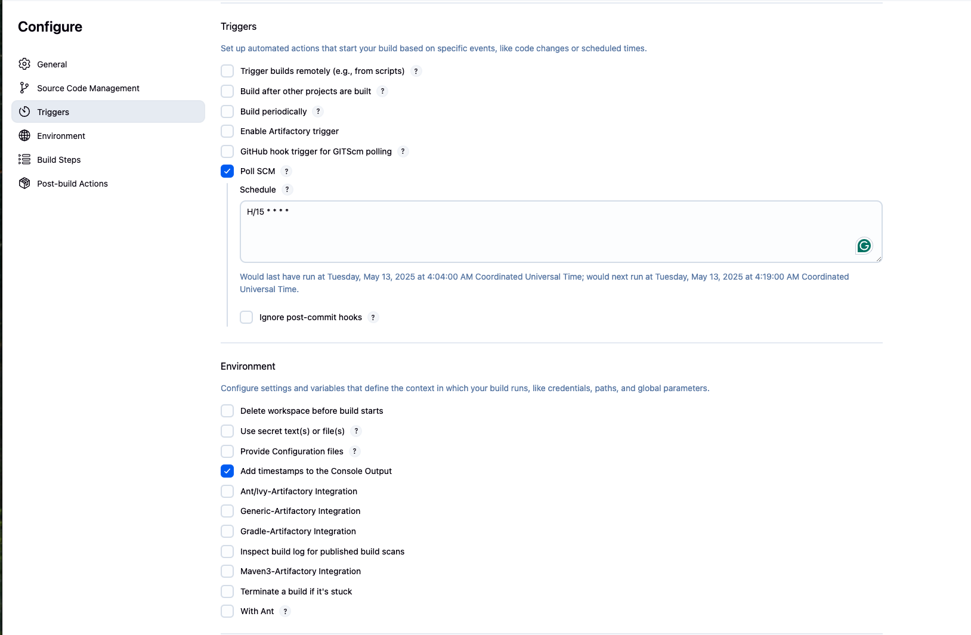

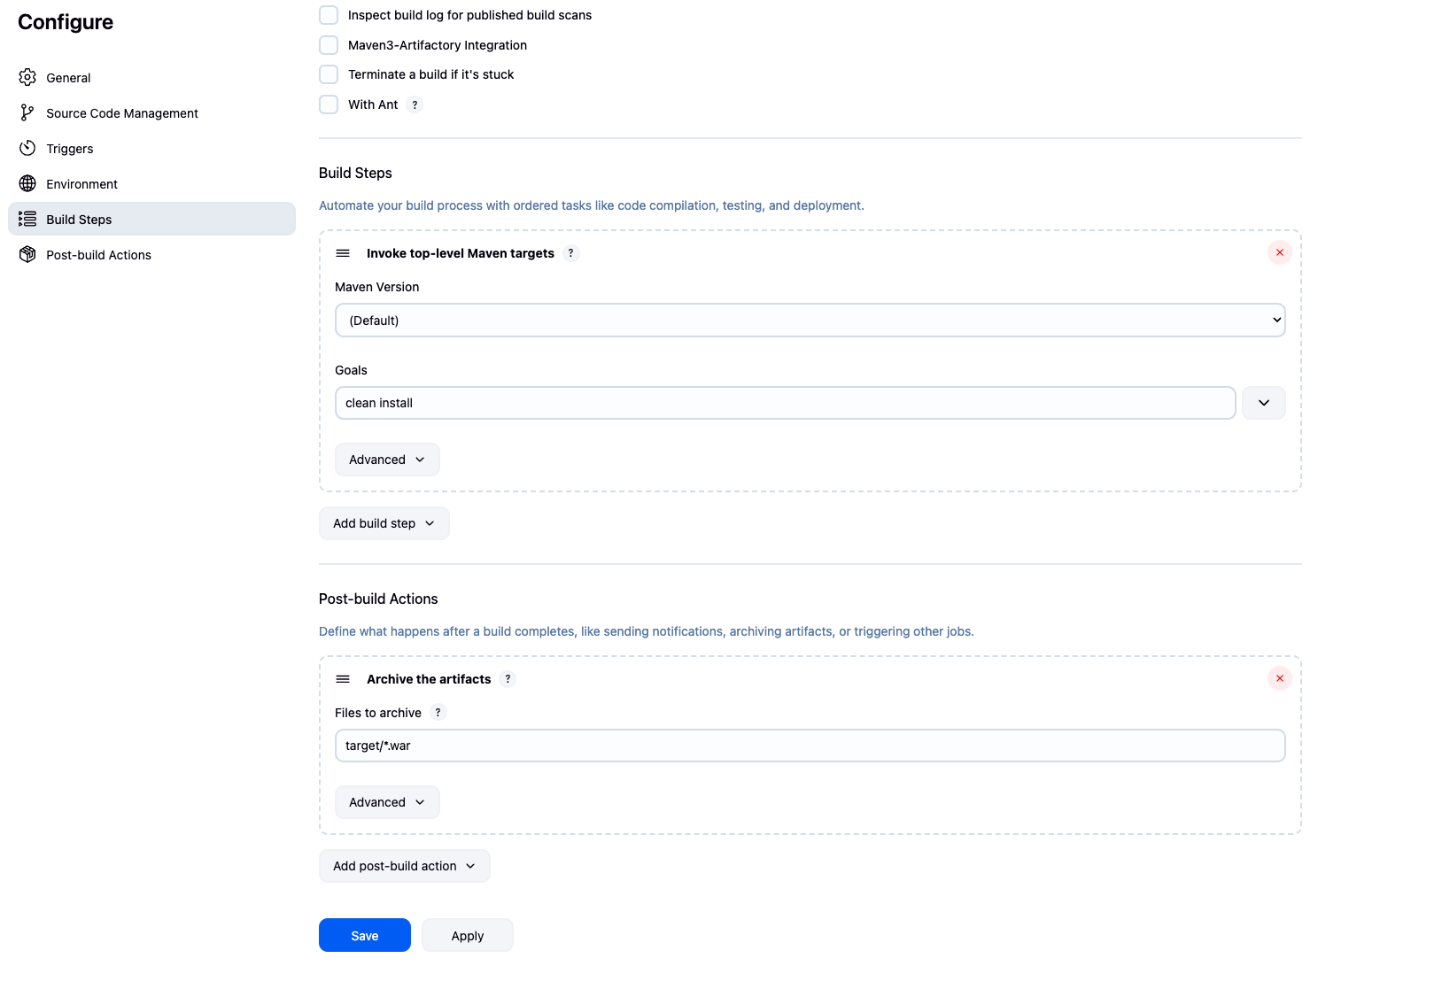

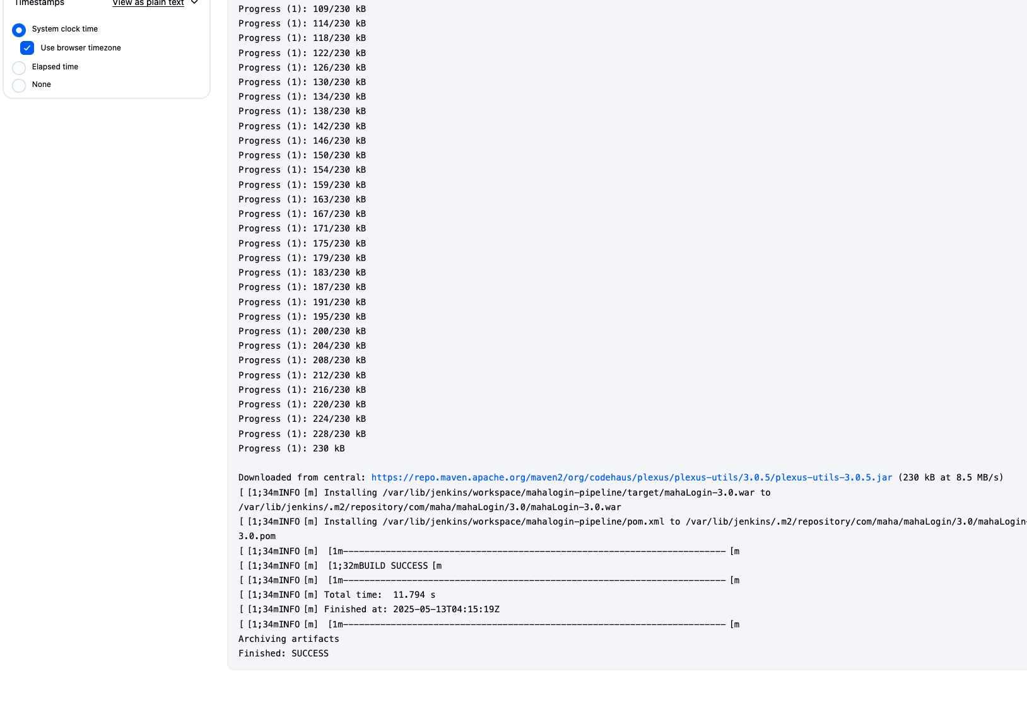

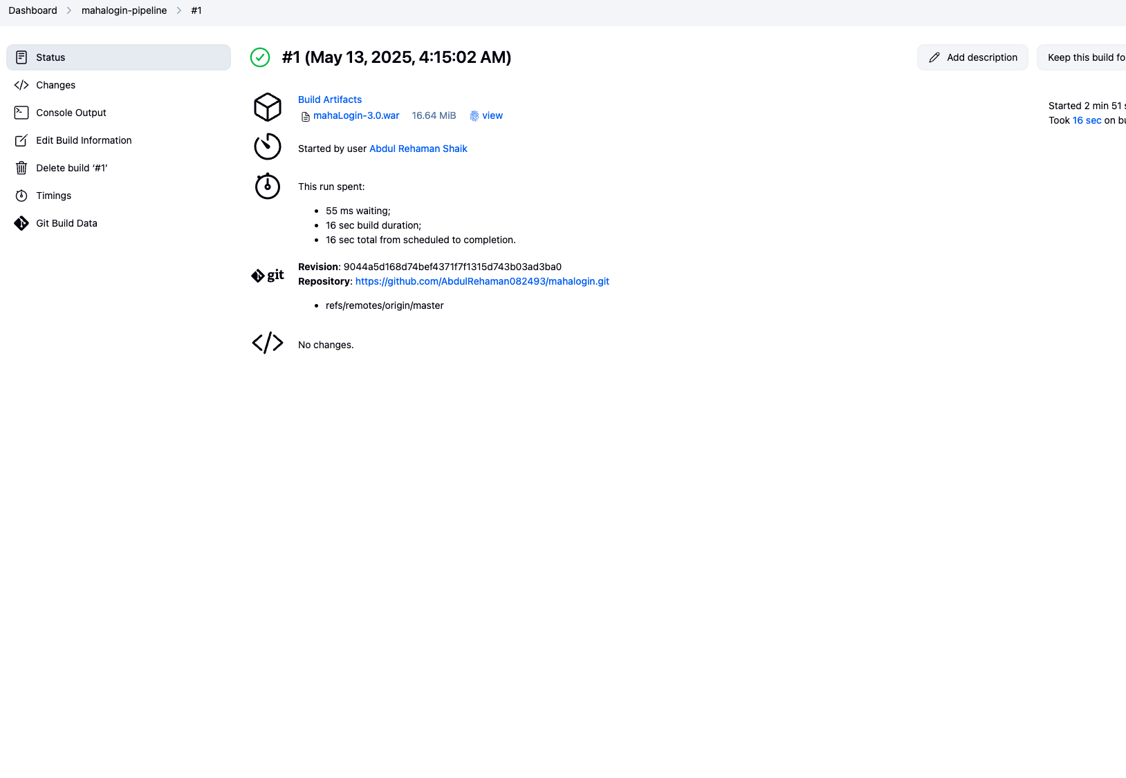

b. Night Builds (Clean Build on SIT/UAT)
- Time: Scheduled at 2:00 AM
- Triggered by: Cron 2 * * * * (or similar)
- Steps:
  - Clean Workspace
  - Clone from SCM
  - Maven Clean + Compile + Install
  - Generate Artifact
  - Push artifact to remote repo (e.g., JFrog)
  - (Optional) Run Sonar analysis
  - Run functional test cases
  - (Optional) Run performance test cases (if needed)

🌙 Jenkins Night Build (Clean Build) Setup — SIT/UAT

✅ Objective:
Schedule a nightly job in Jenkins that performs a clean build from Git, compiles and tests the Java project using Maven, and pushes the artifact to JFrog Artifactory.

🧩 Step 1: Create a Freestyle Jenkins Job
- Go to Jenkins Dashboard → Click New Item
- Enter name: night-build-mahalogin-SIT
- Choose Freestyle project
- Click OK
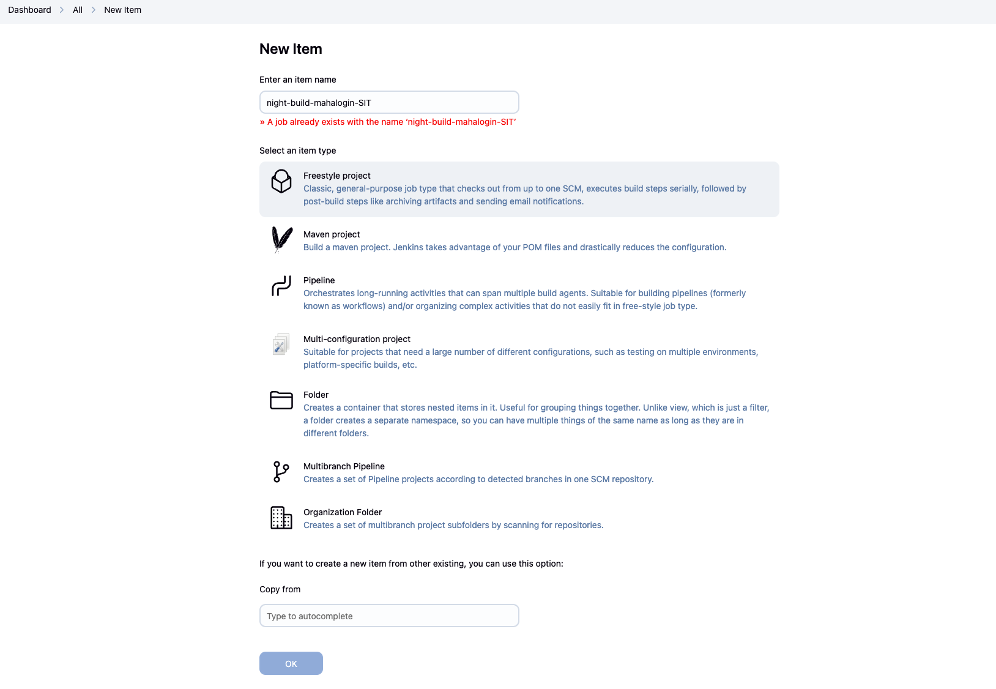

🔗 Step 2: Source Code Management
- Select Git under Source Code Management
- Repository URL: https://github.com/AbdulRehaman082493/mahalogin.git
- Credentials: Add GitHub credentials if private repo
- Branch Specifier: */SIT
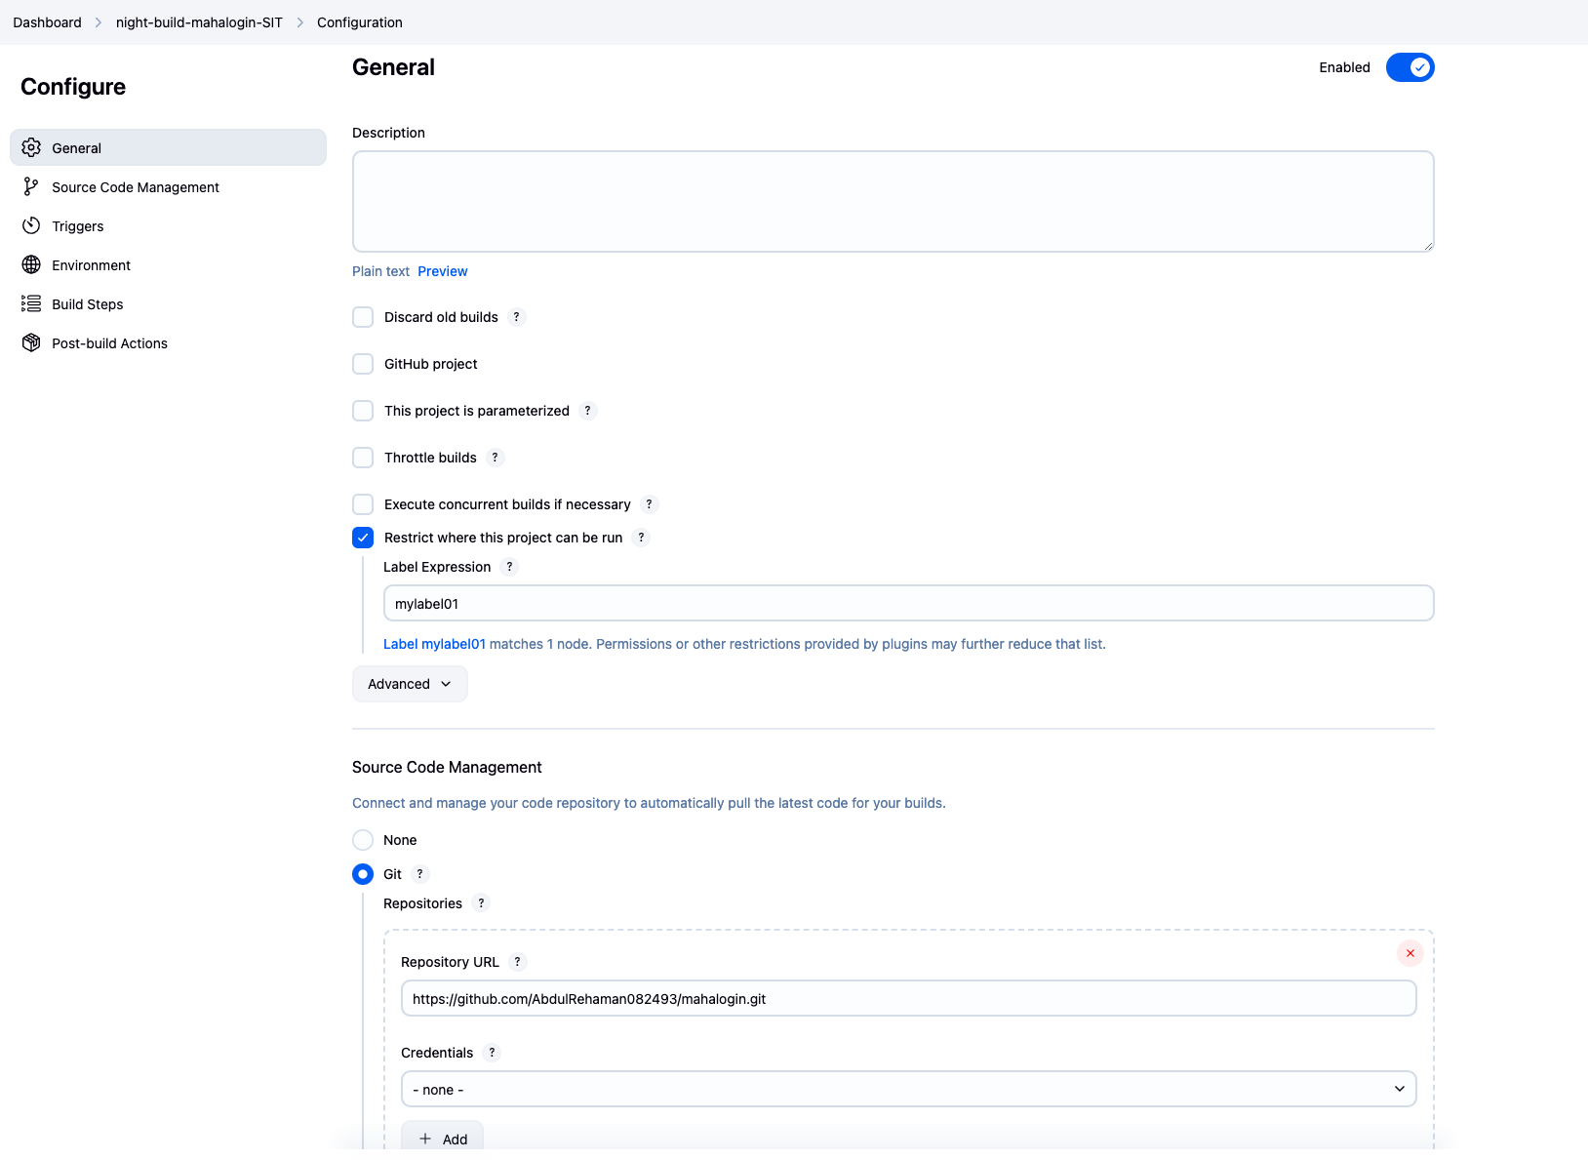

⏰ Step 3: Trigger by Cron (Schedule at 2:00 AM)
- Go to Build Triggers
- Select Build periodically
- Add the following CRON: 0 2 * * *
🕑 Triggers the build every day at 2:00 AM
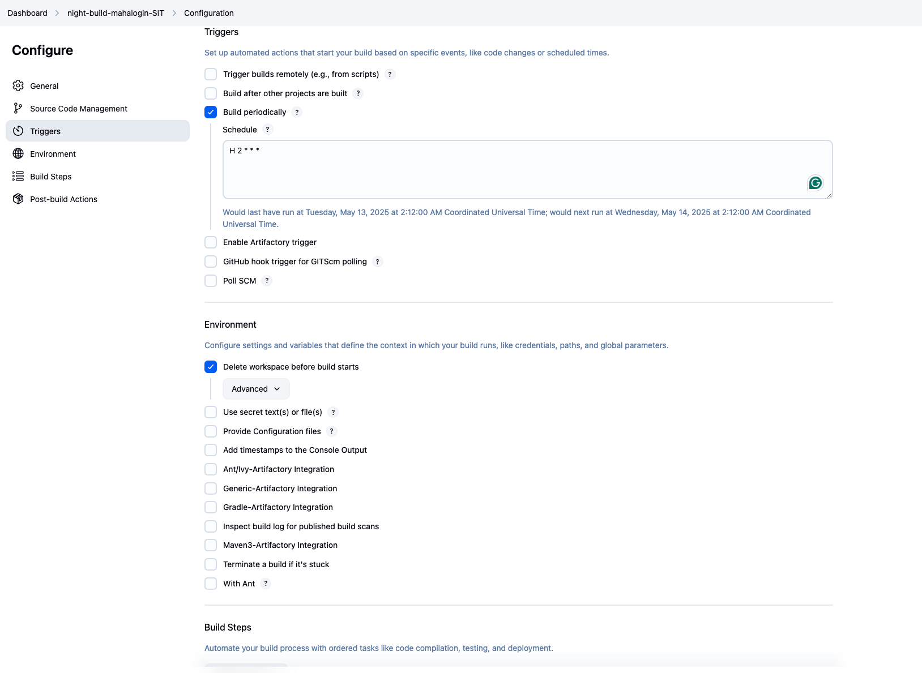

🧹 Step 4: Clean Workspace Before Build
- Go to Build Environment
- Check ✅ Delete workspace before build starts

⚙️ Step 5: Build Configuration with Maven
- Go to Build → Add build step → Invoke top-level Maven targets
- Fill in:
  - Goals: clean install
  - POM: pom.xml

📦 Step 6: Archive Artifact
- Go to Post-build Actions
- Select Archive the artifacts
- Set: target/*.war

📤 Step 7: Push Artifact to JFrog Artifactory (Optional)
- Go to Post-build Actions → Deploy artifacts to Artifactory
- Set:
  - Artifact Path: target/*.war
  - Target Repo: Example: libs-release-local
- Configure your JFrog credentials and Artifactory server in Jenkins global config first.

🧪 Step 8: (Optional) SonarQube Code Analysis
If SonarQube is integrated:
- Add Build Step → Invoke SonarQube Scanner
- Provide:
  - Project Key
  - Source Path
  - OR use sonar-project.properties in root directory

✅ Step 9: Run Functional Tests
- Add Build Step → Execute Shell (or Maven goals)
- Example command:
echo "Running Functional Test Cases..."
mvn verify

⚙️ Step 10: (Optional) Run Performance Test Cases
If using JMeter or other tool:
- Add Build Step → Execute Shell
- Example: jmeter -n -t testplan.jmx -l results.jtl

📘 Summary Table

Step | Task | Description
1 | Cron trigger | 0 2 * * * to run at 2:00 AM
2 | Git checkout | From SIT or UAT branch
3 | Clean workspace | Ensure clean environment
4 | Maven build | Run clean install
5 | Archive .war | Save artifacts
6 | Push to Artifactory | Optional for deployment
7 | SonarQube Analysis | Optional code quality
8 | Functional Tests | Ensure working build
9 | Performance Tests | Optional if configured

🔄 Steps: JFrog Artifactory Integration with Jenkins for Artifact Upload

✅ Goal:
After building the mahalogin project with Maven, automatically upload the .war file to JFrog Artifactory using Jenkins.

🔧 Prerequisites:
- Jenkins installed and running
- JFrog Artifactory server running (OSS or Pro)
- Artifactory URL & credentials (username/API key/password)
- Jenkins plugins installed:
  - Artifactory Plugin
  - Maven Integration Plugin
- .m2/settings.xml (optional) for authenticated deploys

📘 Step-by-Step Configuration:

🔹 Step 1: Configure Artifactory in Jenkins
- Go to Jenkins Dashboard → Manage Jenkins
- Click Configure System
- Scroll to JFrog Artifactory
- Click Add Artifactory Server
  - Server ID: jfrog-sit
  - URL: http://<your-artifactory-host>:8081/artifactory
- Add Credentials:
  - Username/API Key + Password
- Click Test Connection → ✅ Should be successful

🔹 Step 2: Create a Jenkins Job for SIT/UAT Build
- Go to New Item → Enter name: SIT-night-build-artifact
- Choose Freestyle project
- Under Source Code Management, configure Git:
Repo URL: https://github.com/AbdulRehaman082493/mahalogin.git
Branch: */SIT or */UAT

🔹 Step 3: Add Maven Build Step
- Under Build Environment, check ✅ Delete workspace before build
- Under Build → Add build step → Invoke top-level Maven targets
- Set:
  - Goals: clean install deploy
  - POM: pom.xml
deploy phase will push the .war to Artifactory (requires distributionManagement section in POM or global Jenkins config override)

🔹 Step 4: Use Jenkins Artifactory Plugin (Optional Method)
Instead of direct Maven deploy, you can use:
- Under Post-build Actions → Select:
Deploy artifacts to Artifactory
2.Configure:
  - Repository Key: mySITrepo
  - Artifact Pattern: target/*.war
  - Target Path: libs-release-local/com/mahalogin/

🔹 Step 5: SCM Polling or Scheduling
Under Build Triggers:
- Use Cron for nightly builds: 0 2 * * * # Every day at 2:00 AM

🔹 Step 6: Save and Run Job
- Click Save
- Click Build Now
- Go to Console Output and ensure:
  - Build success
  - .war file uploaded to Artifactory under mySITrepo

🗂️ Artifactory Repo Pattern Reference
Setting | Example
Target Repo | mySITrepo
Pattern | target/*.war
Upload Location | /libs-release-local/
Deploy Method | mvn deploy or Plugin

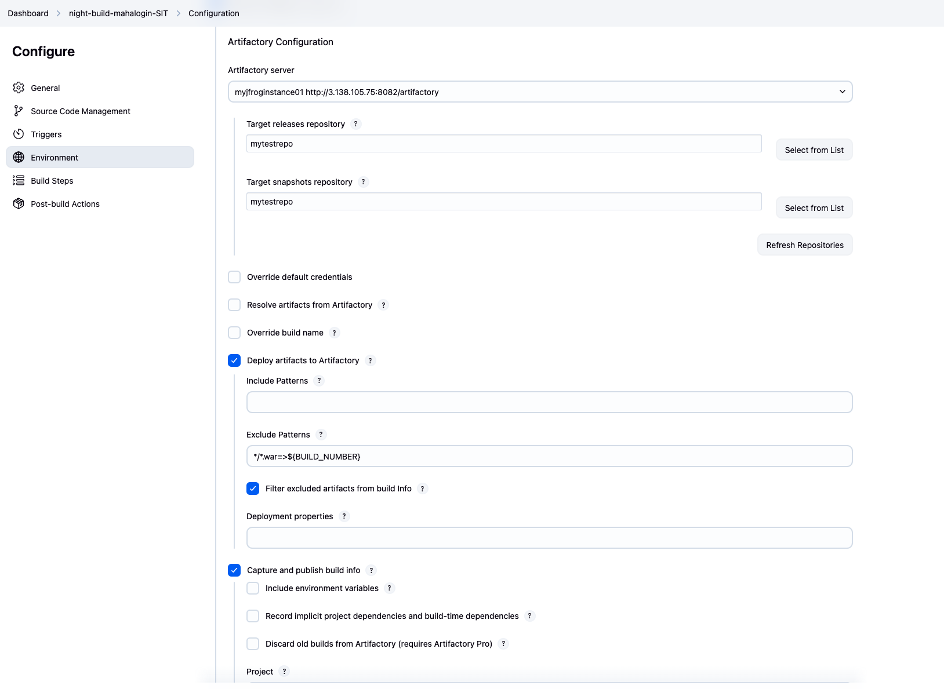

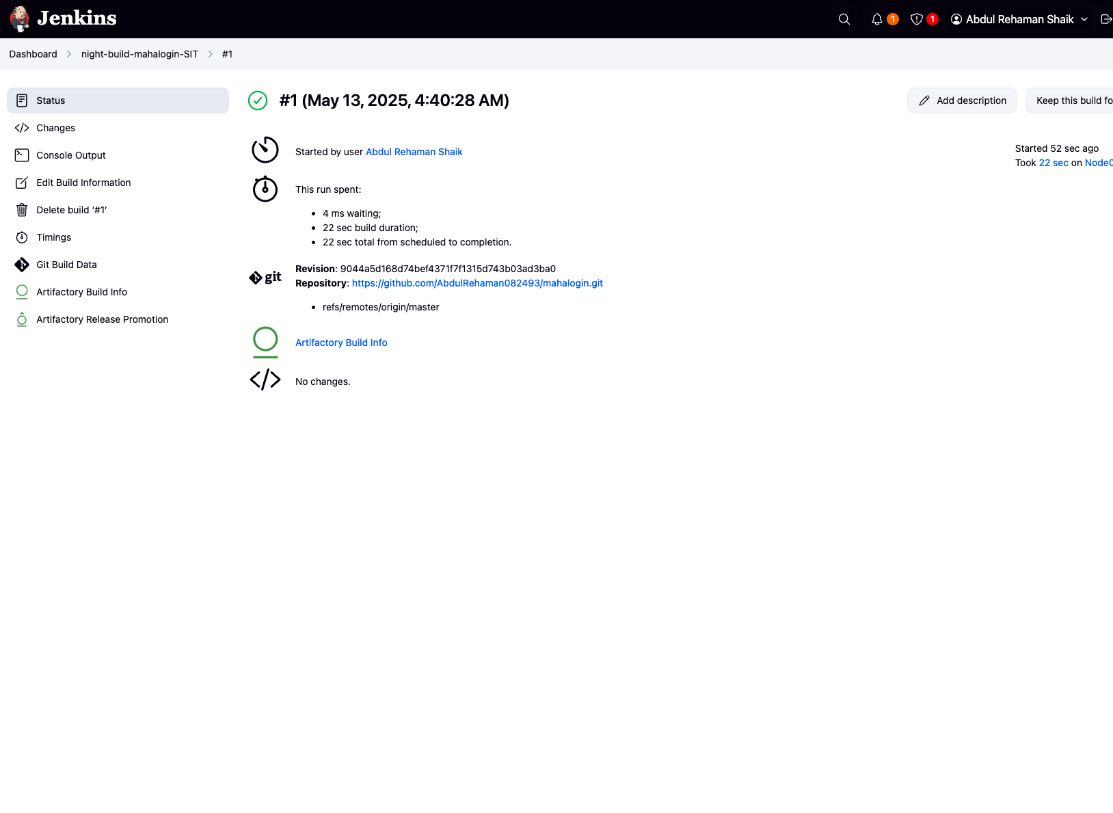

✅ 3. Jenkins Backup Strategy Using ThinBackup Plugin

🔧 Purpose:
To regularly back up Jenkins configurations, job details, build results, user content, and plugins — and store them in a defined backup folder.

🧩 Step-by-Step Backup Configuration

🔹 Step 1: Prepare Backup Directory
SSH into your Jenkins server and create the backup folder:
sudo mkdir -p /home/ubuntu/myjenkinsbackup
sudo chown jenkins:jenkins /home/ubuntu/myjenkinsbackup

(base) abdulrehamanshaik@MacBookPro Linux % ssh jenkinsmaster@74.235.253.152
jenkinsmaster@74.235.253.152's password:
Welcome to Ubuntu 22.04.5 LTS (GNU/Linux 6.8.0-1028-azure x86_64)

* Documentation: https://help.ubuntu.com
* Management: https://landscape.canonical.com
* Support: https://ubuntu.com/pro

System information as of Tue May 13 05:07:50 UTC 2025

System load: 0.0 Processes: 128
Usage of /: 13.1% of 28.89GB Users logged in: 0
Memory usage: 13% IPv4 address for eth0: 10.0.0.4
Swap usage: 0%

* Strictly confined Kubernetes makes edge and IoT secure. Learn how MicroK8s
just raised the bar for easy, resilient and secure K8s cluster deployment.

https://ubuntu.com/engage/secure-kubernetes-at-the-edge

Expanded Security Maintenance for Applications is not enabled.

4 updates can be applied immediately.
To see these additional updates run: apt list --upgradable

2 additional security updates can be applied with ESM Apps.
Learn more about enabling ESM Apps service at https://ubuntu.com/esm

New release '24.04.2 LTS' available.
Run 'do-release-upgrade' to upgrade to it.

Last login: Mon May 12 19:22:25 2025 from 98.156.1.186
jenkinsmaster@JenkinsMaster:~$ sudo -i
root@JenkinsMaster:~# sudo mkdir -p /home/ubuntu/myjenkinsbackup
sudo chown jenkins:jenkins /home/ubuntu/myjenkinsbackup
root@JenkinsMaster:~#

🔹 Step 2: Install ThinBackup Plugin
- Go to Jenkins Dashboard → Manage Jenkins
- Click Manage Plugins
- In the Available tab, search for ThinBackup
- Check it and click Install without restart

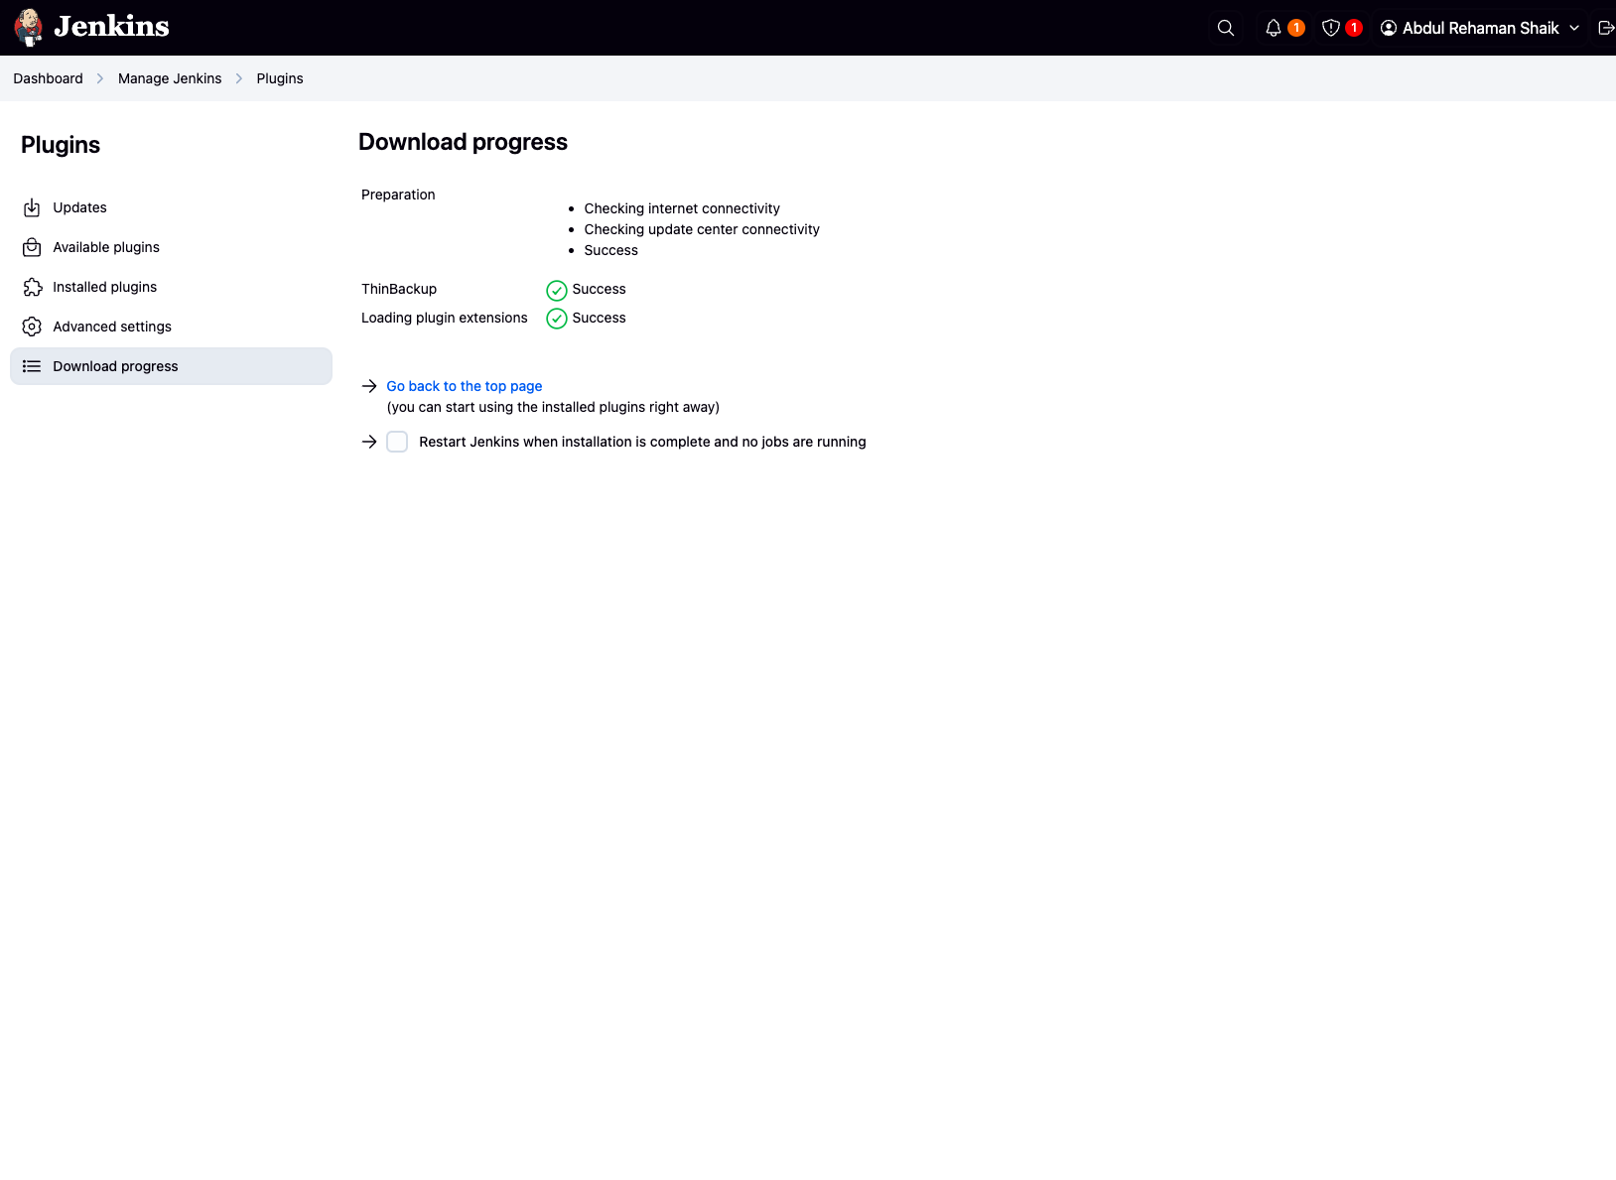

🔹 Step 3: Configure ThinBackup
- Go to Manage Jenkins → ThinBackup
- Click ThinBackup Settings
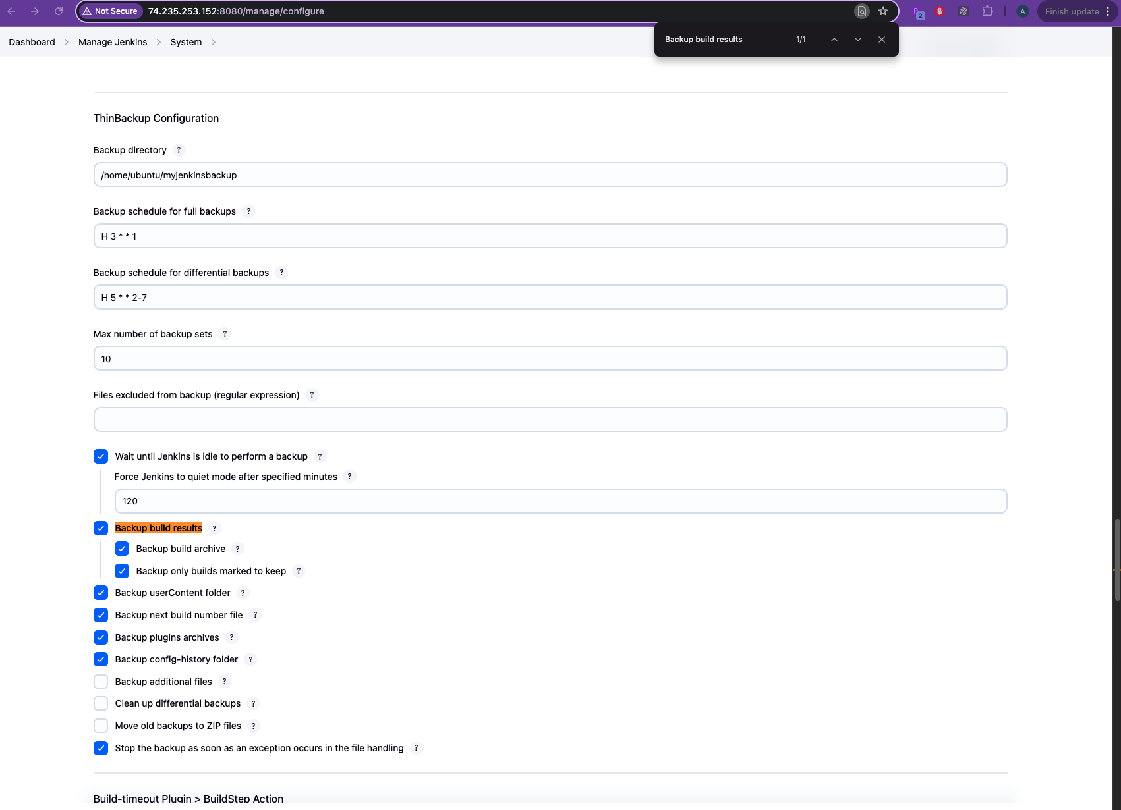
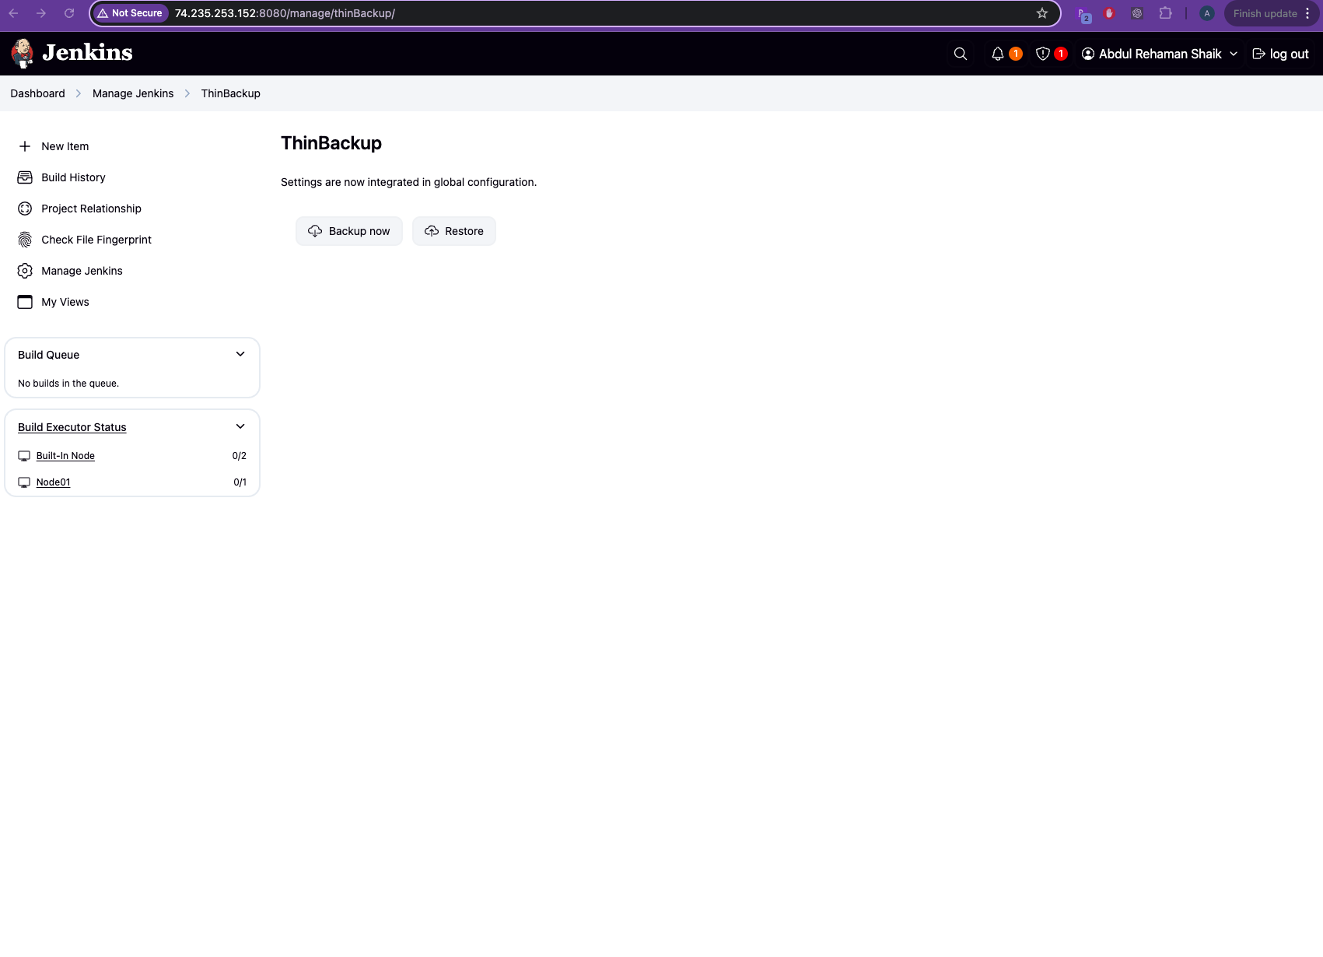
- Configure the following:

Field | Value
Backup directory | /home/ubuntu/myjenkinsbackup
Full backup schedule | H 3 * * 1 (Every Monday at 3 AM)
Differential backup | H 5 * * 2-7 (Tue–Sun at 5 AM)
Maximum number of backups | e.g., 10
Backup build results | ☑️
Backup archived artifacts | ☑️
Backup user content | ☑️
Backup build nodes config | ☑️
Backup job configs | ☑️
Backup plugins | ☑️
Backup next build number | ☑️

✅ Also check: Cleanup old backup directories (keep zip)

🗂️ What Gets Backed Up
- ✅ Build results (build logs, output)
- ✅ Archived artifacts (*.war, *.jar, etc.)
- ✅ User content folder (/userContent)
- ✅ Plugins
- ✅ Job configurations (config.xml)
- ✅ Global Jenkins config (config.xml, credentials.xml)
- ✅ Next build number tracking

📅 Scheduling Reference (CRON Format):

Schedule Type | CRON | Meaning
Full Backup | H 3 * * 1 | Every Monday at 3:00 AM
Diff Backup | H 5 * * 2-7 | Tue to Sun at 5:00 AM
Use H instead of fixed minutes for load balancing across Jenkins masters.

✅ 4. Jenkins Restore Strategy with ThinBackup
When needed, you can restore Jenkins from a backup ZIP created by ThinBackup.

🔁 Step-by-Step Restore Process

🔹 Step 1: Go to Restore Menu
- Jenkins Dashboard → Manage Jenkins
- Click ThinBackup
- Choose Restore

🔹 Step 2: Choose a Backup Version
- You’ll see a list of available backup timestamps
- Select a backup version (latest or specific date)
- Click Restore

🔹 Step 3: Restart Jenkins
- After restore, restart Jenkins manually for all restored configs and plugins to take effect:
sudo systemctl restart jenkins

♻️ What Gets Restored

Component | Restored
Jenkins plugins | ✅
Job configurations | ✅
Build numbers | ✅
Global settings | ✅
Archived artifacts | ✅
Build logs | ✅

📝 Notes and Best Practices
- ✔️ Store backup folder on external storage or mount to S3/NFS if needed.
- ✔️ Backup directory should have write access by the jenkins user.
- ❌ Avoid restoring during an active build — stop Jenkins if needed before restore.
- 📦 ThinBackup creates backup as .zip — good for offline and portable recovery.

Last login: Mon May 12 19:22:25 2025 from 98.156.1.186
jenkinsmaster@JenkinsMaster:~$ sudo -i
root@JenkinsMaster:~# sudo mkdir -p /home/ubuntu/myjenkinsbackup
sudo chown jenkins:jenkins /home/ubuntu/myjenkinsbackup
root@JenkinsMaster:~# ls -al /home/ubuntu/myjenkinsbackup
total 12
drwxr-xr-x 3 jenkins jenkins 4096 May 13 05:23 .
drwxr-xr-x 3 root root 4096 May 13 05:08 ..
drwxr-xr-x 7 jenkins jenkins 4096 May 13 05:23 FULL-2025-05-13_05-23
root@JenkinsMaster:~# ls -al /home/ubuntu/myjenkinsbackup
total 16
drwxr-xr-x 4 jenkins jenkins 4096 May 13 05:24 .
drwxr-xr-x 3 root root 4096 May 13 05:08 ..
drwxr-xr-x 7 jenkins jenkins 4096 May 13 05:23 FULL-2025-05-13_05-23
drwxr-xr-x 7 jenkins jenkins 4096 May 13 05:24 FULL-2025-05-13_05-24
root@JenkinsMaster:~#

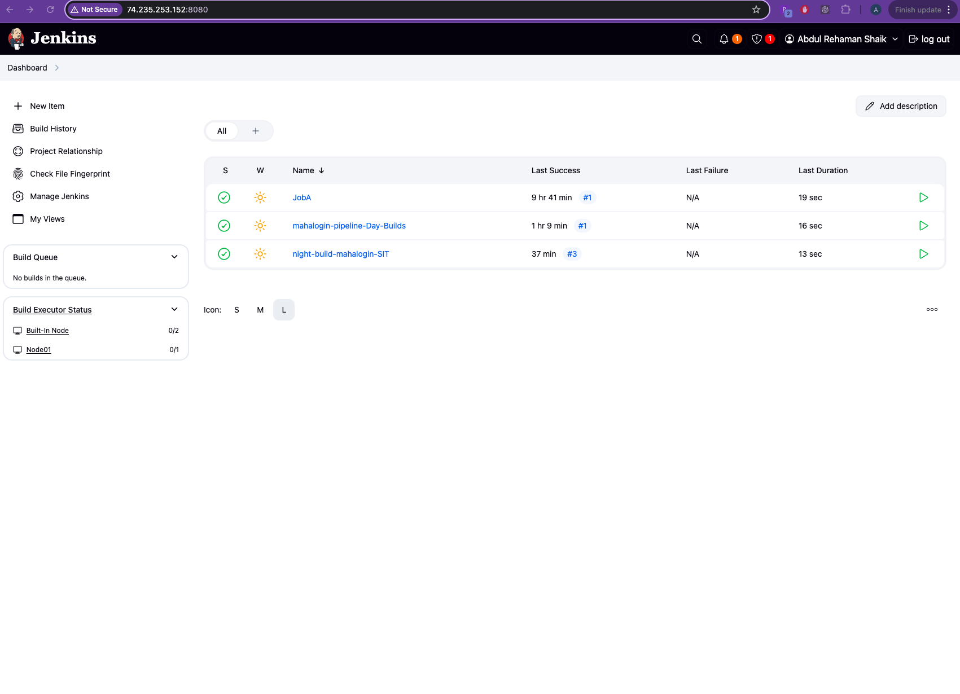

Deleted JobA

